**﻿ AGGLOMERATIVE CLUSTERING**

**Business Problem** = ﻿ ﻿﻿﻿Perform Clustering for the crime data and identify the number of clusters.

* **Name of the File: -** crime_data.csv
* **Size of the File: -** 4 KB
* **Data: -** 51 Observation, 5 Variable
* **Missing Value: -** Data don’t have Missing Values

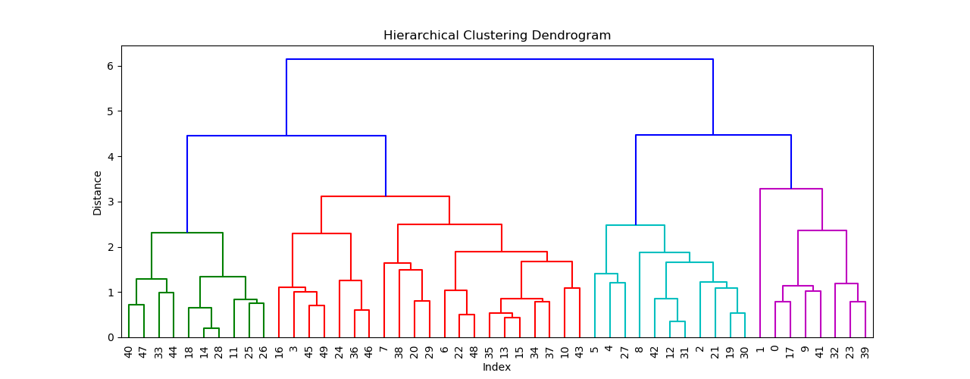**Dendrogram = ﻿**

**Inferences = ﻿** In Crime dataset there are listed rates of different types of crime such as murder, assault, urban pop, rape as per different cities. After Grouping them we can clearly differentiate them into four main clusters based on the crime rate. Using clusters we can conclude that Cities in cluster 3 are safest because cluster 3 has a very low crime rate among all and Cities in clusters 0 and 2 are very dangerous because they are having high crime rate. Cluster 1 showing a moderate crime rate of cities. So with the help of clustering, we easily different cities into dangers, safe and safest with respective crime rate and

we can improve their law & order accordingly to control crimes.

**Python code file**: - [Crime Data Analysis.py](https://github.com/nilaydeshmukh0/Agglomerative-Clustering/blob/master/Crime%20Data%20Analysis/Crime%20Data%20Analysis.py)